Set up a Qualtrics survey so that participants must log in with their HarvardKey
- Edit the Survey Flow
  - Go into a survey and click on “Survey Flow"
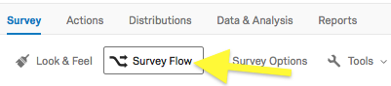
  - Add a new element
  - Choose "Authenticator"
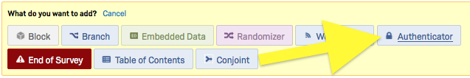
  - For Authentication Type choose "SSO"
  - Check “Capture respondent identifying info” then use the green “+” button to map three fields:
firstname = firstname
lastname = lastname
email = email
(These fills need to be matched exactly)
  - For SSO Type choose "Token". Choose "AES128" as the Encryption Method.
Note that after setting this up, using the Preview Survey feature will not work correctly.
  - Click on the "Generate Key" link; you'll see random characters in the Key field.
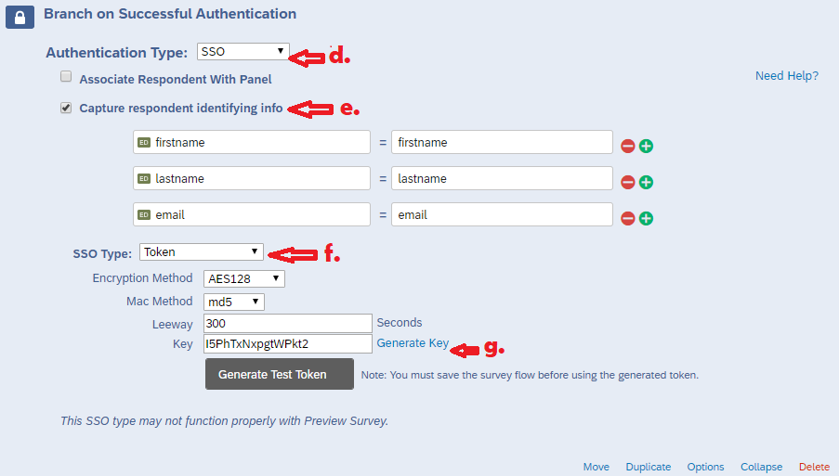
  - Make sure this Authenticator block is the first element at the very top of your Survey Flow. If it isn't, click on "Move" to drag and drop it to the top. Also be sure that all subsequent question blocks or branches are nested beneath the Authenticator block so respondents must authenticate before they can view the survey questions.
  - Click "Save Flow"
- Confirm your Survey Options
  - Click on “Survey Options”
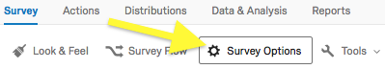
  - Survey Protection should be set to "Open Access":
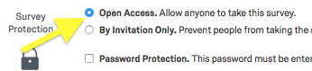
- Get a Required Distribution Link
  - Click on the Distribute Survey tab, and copy the Anonymous Survey Link there. Note that this is NOT the link you should distribute to users.
  - Go to the Qualtrics Login Link Generator and paste your survey URL into the form on that page.
  - The tool will provide you with a special link that you should send to your recipients. You must use this link when requesting people to fill out your survey. For authentication to work, this is the only link you should distribute for people to take your survey.
- Embed Survey to Canvas
  - If you have an existing page you would like to edit, navigate to the page and click on Edit. If not, create a new page in Canvas. In the edit screen, click on the HTML Editor option to the right of the editing toolbar, as shown below:
  - Paste the code below into your Canvas HTML editor:
<iframe style="display: block; margin-left: auto; margin-right: auto;" src="Replace with Survey Link" width="100%" height="800px" name="Sample Survey"></iframe>
You will replace bold text above with the survey link from Qualtrics. The width and height can be adjusted as needed. The name is not visible and only serves more so as an organizational object.
- Check the results of the survey:
Go to Data Analysis tab of Qualtrics, click on the “Tools” on the top-right. Then select “Choose Columns”>”Embeded Data”, select “firstname, lastname, email”.
